Multi Platform Arcade Game Designer

Version 0.7.7

Jonathan Cauldwell
March 2020

Part 1: Windows Editors

The WinAGD program has editors for window size, blocks, sprites, objects, screens, map layout, object positions, sprite positions, font, palette and keyboard controls. These editors will create data for the ZX Spectrum, Timex TC2048, Amstrad CPC464, Acorn Atom, MSX, Dragon, Acorn Electron and Spectrum Next. At the present time the Timex shares its graphics with the Spectrum Next. The Atom shares its graphics with the Dragon and Acorn Electron. The MSX shares its sprites with the ZX Spectrum. Colour Atom and Dragon editors are planned and it is anticipated that these will also share graphics. Other machines will be added as volunteers come forward to convert the engine and compiler.

Copying and pasting graphics is possible between formats wherever differences between graphic formats are not too great. There is also a set of tools to convert all game graphics from some formats to others.

Window size and Screen Layout

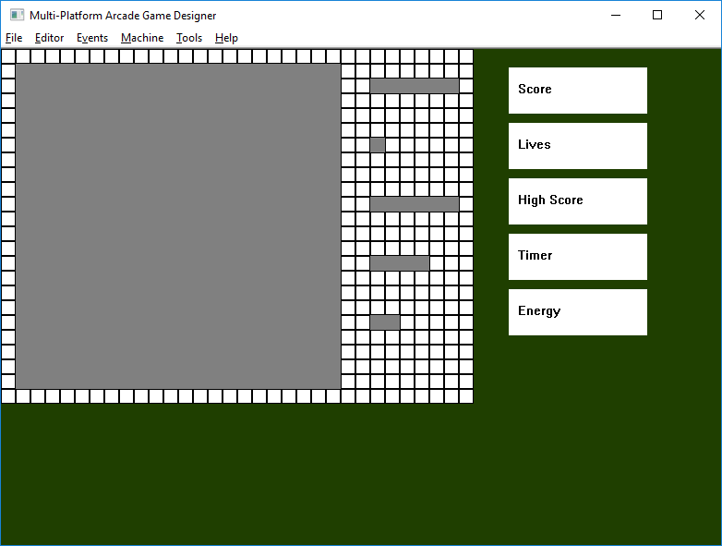
This is where the main screen layout is defined. You will need to define the position of the main window and if you are intending to use the scripts generator to quickly create some code for your game you will need to define positions for any other elements required in your game, such as the displays for score and lives. The play area is essential but you may pick and choose a number of other elements to include in your game, so their displays can be toggled on and off using the buttons on the right.

Click on any enabled elements to select them and then move each one around the screen using the cursor keys. Alternatively, reposition an item with the mouse by clicking another cell to select the top left corner of its new position. The main play area will require 2 opposite diagonal corners to be clicked in order to specify its size and position. Should the size change you will be required to confirm the new size as this will invalidate any existing screen layouts.

As an alternative to clicking the boxes on the right these keyboard shortcuts are available:

E energy on/off
H high score on/off
L lives on/off
S score on/off
T timer on/off

Blocks

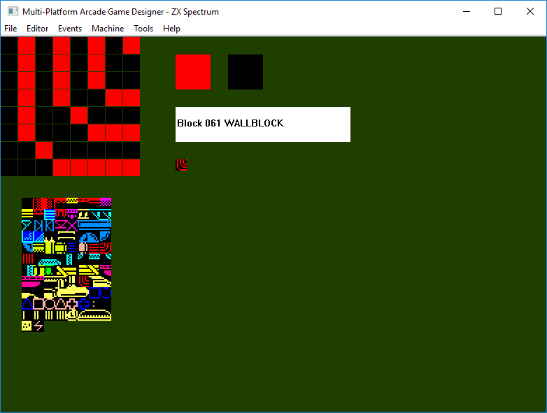
These are the individual building blocks used to make up the screens in a game. Each block needs to be assigned a type to determine the way in which it interacts with sprites during the game. The available types are:

- EMPTYBLOCK empty space, sprites pass through
- PLATFORMBLOCK platform, sprites pass through except when moving down
- WALLBLOCK solid walls, sprites do not pass through
- LADDERBLOCK can be detected with LADDERABOVE and LADDERBELOW to make sprites ascend and descend
- FODDERBLOCK similar to WALLBLOCK but can be shot away by lasers or removed with DIG
- DEADLYBLOCK contact with these can be detected with IF DEADLY
- CUSTOMBLOCK like DEADLYBLOCK, contact can be detected with IF CUSTOM
- WATERBLOCK empty space, not yet implemented
- COLLECTABLE picked up with GETBLOCKS command, triggers a COLLECTBLOCK event

Use the mouse to draw blocks, selecting new ones from the block bank to the right of the grid. In addition, use the following keys:

Left arrow/1 Previous block
Right arrow/2 Next block
Insert/X Create new block
Delete Delete block
M Copy block
K Paste block
R/T Select block type
H Flip block horizontally
V Flip block vertically
I Invert block (not Amstrad CPC)

It is possible to copy a block to the clipboard, switch to another machine and paste it in to the block for the second machine. Graphics formats differ between formats but MPAGD will do the conversion automatically, converting the block to the closest available match on the target machine. In some cases you may wish to fine-tune the results manually.

Sprites

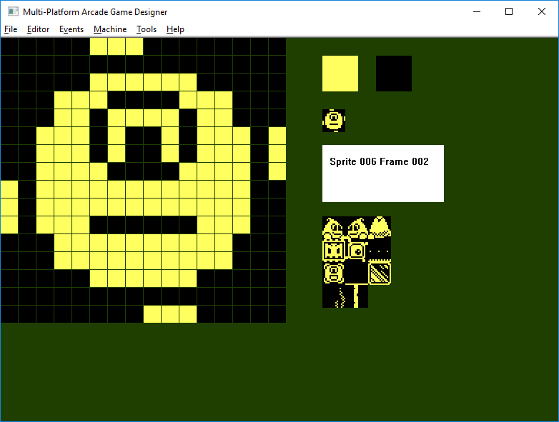
Use the mouse to design sprites. Select the sprite to be edited from the sprite bank positioned to the lower right of the window. The following keys are available:

Arrows Shift sprite around grid
1 Previous sprite
2 Next sprite
D/F Step through sprite frames
Insert/X Create new sprite
Delete Delete sprite
I Create new frame
R Remove frame
M Copy sprite
K Paste sprite
H Mirror sprite horizontally
V Flip sprite vertically
G Grab sprite from scratchpad

It is possible to copy a sprite to the clipboard, switch to another machine and paste it in to the block for the second machine in just the same way as for blocks.

Single or multi frame Sprites may be imported from SevenUp files. To do this, simply select the Import sprite option from the File menu then choose the .SEV file you wish to import. The new sprite will be automatically created for you.

Sprites may be drawn elsewhere on 256 x 192 pixel screens then grabbed one frame at a time from the scratchpad. To import a sprite screen select the Import scratchpad screen from the File menu and choose a screen file to import. MPAGD will determine the format of the screen based on the file length. Once the scratchpad is loaded you should return to the sprite editor and press G to grab a sprite. You can then select the area with the mouse button. This will copy the sprite frame to the clipboard so it can then be pasted into a sprite frame. In this way it is possible to import screens drawn on any of the supported machines with 256 x 192 pixel resolutions, grab sprites and then pasted them into the sprite grid for any other format.

Objects

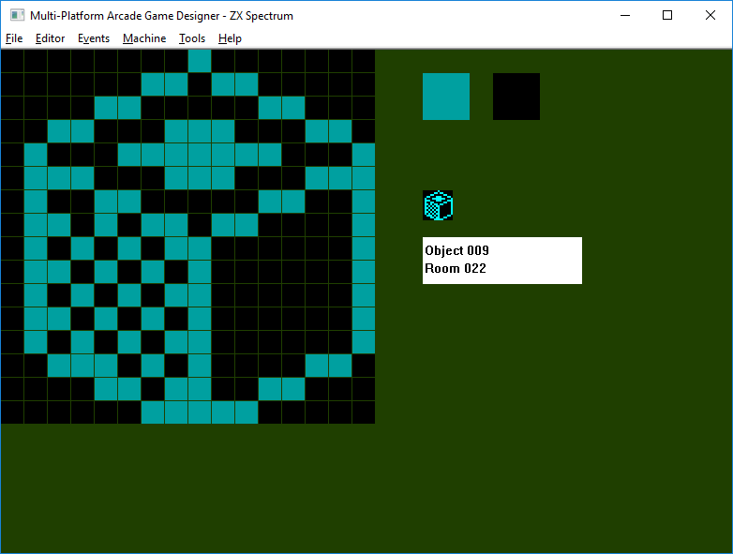
Use the mouse to design objects.

Left arrow/1 Previous object
Right arrow/2 Next object
Insert/X Create new object
Delete Delete object
Up/Down Change object’s start room
P Set starting position in room (position with mouse then enter to return)
M Copy object
K Paste object

Screens

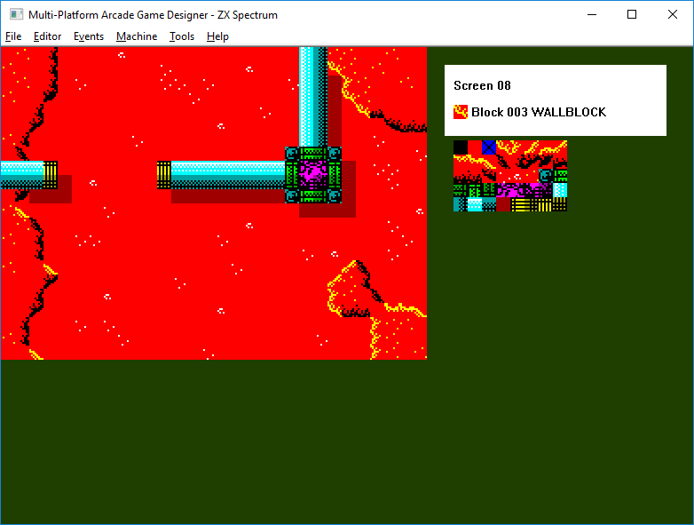
Select blocks from the bank to the right of the screen layout. A left click will place a block on screen, right click will undo the last block placement.

1 Previous screen
2 Next screen
3 Previous block
4 Next block
Insert/X Create new screen
Delete Delete screen
M Copy screen
K Paste screen
Cursors Scroll screen with wrap-around

Map

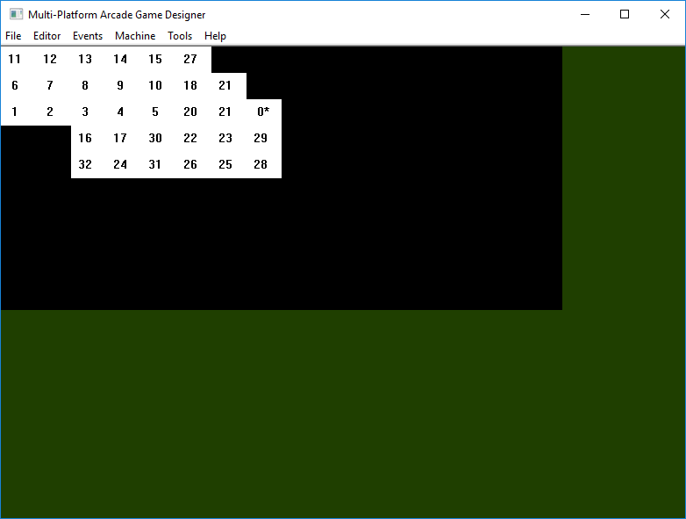
Use the left and right mouse buttons to select the screen to appear at each grid position.

Cursors Move map around grid
Space/Enter/X Set start screen

Font Editor

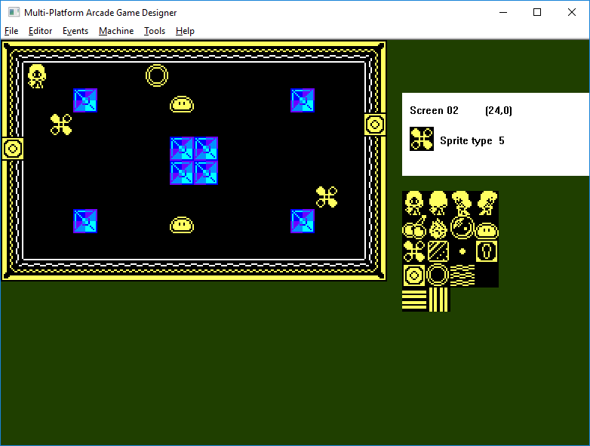
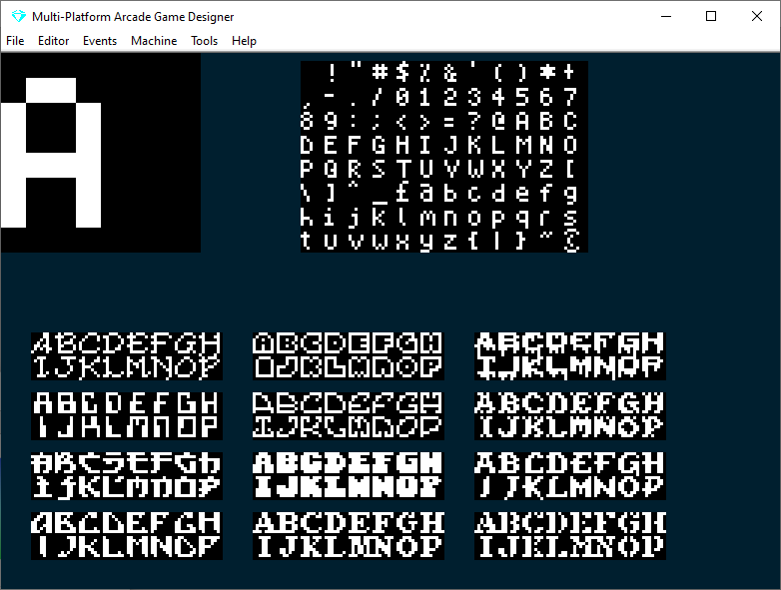
The font editor allows you to select characters from the table on the right and edit them in the grid in the top left. The cursor keys can be used to scroll each character around the grid. Keys 1 and 2 can also be used to select characters.

The default font is a simple 5x8 affair designed for the CPC but there are 12 other fonts built into the program. These were created by Damien Guard, a talented font designer who has produced over 100 8x8 fonts. These can be found at his website here.

Sprite Positions

Select and position sprites using the mouse. New sprites can be added to the screen by left clicking a sprite image from the selection on the right. AGD will create a new sprite in the top left corner of the selected screen and will attempt to assign a default sprite type for this sprite. You can also change the currently selected sprite’s image by clicking a new sprite from the selection. To change the sprite type, left click the white status panel. The following keyboard controls are also available:

Left arrow Previous screen
Right arrow Next screen
Up/Down Change sprite ink colour (MSX only)
X/Insert Create new sprite on screen
Delete Delete selected sprite from screen
U/I Change selected sprite image
R/T Change selected sprite type

Keyboard Controls

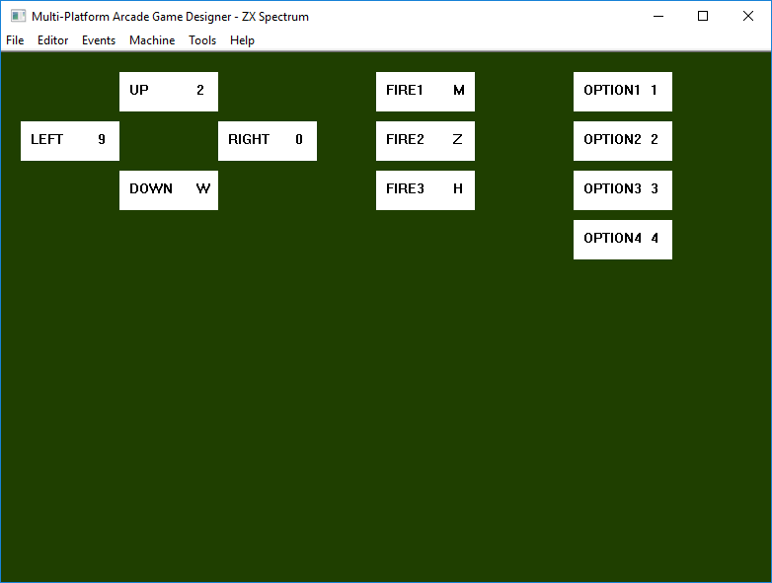
AGD supports up to eleven keyboard controls. The first five correspond to the joystick actions UP, DOWN, LEFT, RIGHT and FIRE respectively. The next two are there to give an extra couple of fire buttons, a menu selector or a pause key. The final four are options keys you may wish to use in a control menu at the start of the game. However, you could just as easily use these in the game proper as well. The key names for use in your events code are UP, DOWN, LEFT, RIGHT, FIRE1, FIRE2, FIRE3, OPTION1, OPTION2, OPTION3 and OPTION4.

To change a key, first left-click on it. A black box should be shown around the key in question to show that it is ready to be defined. Press the key you wish to perform this function and the definition should change.

Script Generator

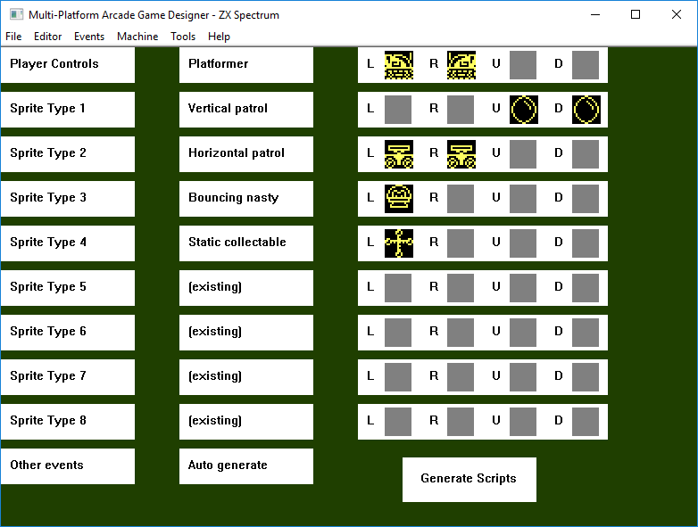
This is a very powerful tool that will generate the basic code for your game and is a very good way of getting started, especially for beginners. More experienced users will still find this feature extremely useful as a quick way of getting the basic code in place.

There are nine sprite type events, one for the player and eight to be used for enemies, collectables or anything else and these are displayed in a table with one row per sprite type. The tenth row is for other events. A sprite template can be selected for each one using the left and right mouse buttons, along with the sprites to use when the sprite is moving in each direction if that is required. Select “(existing)” if you wish to leave a sprite template unchanged.

Selecting “Auto generate” for the last row will automatically generate code for the remaining events. This will include setting up the lives, score and any other displays selected in the Window editor at the start of the game and creating a control menu with redefinable keys.
Click on the Generate Scripts box to create the templates.

The script generator will generate code as intelligently as it can so that the events interact where appropriate. For example, if you set up an energy display in the Window editor it will generate code to run down the energy counter upon contact with enemy sprites and deadly blocks, whereas if no energy display is defined then contact with enemies or deadly blocks will result in the immediate loss of a life.

Rocket Man Controls
This is a player sprite script and allows the user to move the sprite up, left or right and fire. When not moving up the sprite will fall automatically.

Top-Down Controls
A player script allowing the sprite to be moved up, down, left or right.

Platformer
A player control script allowing the sprite to move left and right and jump.

Ladders and Levels
A player script where the sprite can be moved left and right as well as up and down ladders.

Left-to-Right Shmup
A player script allowing the sprite to be moved in all directions and fire to the right. Code for a starfield effect will also be generated.

Static Collectable
This script will animate the sprite while keeping it at the same point on screen. Once collected by the player sprite it will award the player some points and disappear.

Pushable Block
This script will allow the sprite to be pushed around by the player sprite. Hitting another pushable block will prevent the player from pushing it further.

Bouncing Nasty
A deadly enemy script that bounces the sprite diagonally around the screen.

Vertical Patrol
A deadly enemy script that moves the sprite up and down, changing direction when it hits a solid block or the edge of the screen.

Horizontal Patrol
Similar to the horizontal patrol but moves left and right. Will change direction at the edge of a platform.

Ladder Pursuers
Enemy script. Sprites wander around platforms, climbing and descending ladders.

Homing Nasty
An enemy script that slowly moves the sprite towards the player.

Static Nasty
A stationary but animated enemy sprite script.

Player Bullet
Spawned by the player, these sprites can be fired in all directions.

Player Satellite
Sprite for collectables that orbit the player once collected.
AGD Projects

AGD saves projects out as a series of files. The main data block is a .APJ binary file and this contains the map, screen layouts, font, graphics for each machine and a few other things besides.

The events scripts are all stored in their own source files with extensions .A00 to .A20 and messages are stored in a .MSG file. By default AGD fires up Notepad to edit events but you can configure AGD to use a different text or code editor by editing the MPAGD.INI file.

Building Your Game

MPAGD comes with build suites for the major formats, courtesy of Kees van Oss. To test your game, simply press F5 and the toll will attempt to build it. If successful it will fire up an emulator for the relevant machine and run your game. However, you may need to configure your own builds for the less popular formats.

To build a game you will first need to export the code as a .AGD file and these should be saved in the same directory as the compiler. You will then be asked if you wish to build an assembler listing. Click Yes and the relevant compiler will convert your .AGD into an assembly language file that can be assembled to produce your game.

When assembling using the WinApe Amstrad CPC emulator, you might wish to add a line at the start of the assembler listing like this to speed up the process:

nolist

SjAsmPlus is another popular Z80 assembler and will require a line at the start of the code to tell it to produce a binary file as output. A line like this, with spaces at the beginning, is all that is required:

output mygame.bin

You can configure the compiler to produce these lines automatically by tagging a switch to the end of the command line. To produce output for WinApe, use this:

compilercpc mygame -w

To produce output for SjAsmPlus, use this:

compilerzx mygame -s

The ZX Spectrum compiler can be made to build a 128K mode debugger into the code, which allows the user to halt execution in the main loop with the BREAK keys and inspect the sprite parameters and global variables. To include the debugger use the -d switch like this:

compilerzx mygame -d

To get MPAGD to do this for you every time you build, you can write a batch file and edit the MPAGD.INI file to point to your batch file instead of the compiler executable. You could also get it to build the assembler listing at the same time.

Creating an Emulator File

By default, Multi Platform AGD calls a compiler to generate an assembly language listing for the relevant machine but it is possible to configure the program to automatically create emulator files by editing the MPAGD.INI file and changing the compilers batch files.
Kees van Oss has created build suites to create emulator files and it is recommended that these are used to build your game instead as they automate the whole process of building a game.

Edit the MPAGD.INI file with any standard text editor, Notepad will do perfectly well for the job. The default file is set up to create assembler source files and might look something like this:

background_colour = 001f2f
script_editor = notepad
compiler_zx = compilerzx.exe
compiler_timex = compilertmx.exe
compiler_cpc = compilercpc.exe
compiler_atom = compileratom.exe
compiler_drag = compilerdrag.exe
compiler_elk = compilerelk.exe
compiler_next = compilernxt.exe

Let’s say you wish to use Kees’ build suite for the CPC. To do so you will need to change the CPC compiler to use the BUILD batchfile so change the compiler_cpc line in MPAGD.INI:

script_editor = notepad
compiler_zx = compilerzx.exe
compiler_timex = compilertmx.exe
compiler_cpc = build.bat
compiler_atom = compileratom.exe
compiler_dragon = compilerdrag.exe
compiler_electron = compilerelk.exe
compiler_next = compilernxt.exe

The MPAGD.INI file is not case-sensitive.

Here’s an example batch file, zx.bat, to compile a Spectrum game then build a binary using SjAsmPlus:

compilerzx %1 -s
\sjasmplus\sjasmplus %1.asm

The line in MPAGD.INI would look like this:

compiler_zx = zx.bat

Using this, MPAGD would call the batch file to create a binary whenever you build the assembler listing.

Incidentally, you may have noticed that since version 0.7.6 the background colour is configurable in the MPAGD.INI file as a string of six hexadecimal digits like this:

background_colour = 3f0000

The first two digits represent red, the middle two green and the final two digits blue. If you intend to change this setting it might be wise to select a dark colour not available on the machine for which you are developing. Some suggested combinations are 1F3F00 for the original green, 001F2F for blue or 181818 for a dark grey. If the background_colour setting is missing the program defaults to 1F3F00.
Using the 128K Spectrum Debugger

The ZX Spectrum compiler can build a debugger into your code. To use it, you will need to edit your build batch file and add a -d switch to the command line that calls the compiler. You will also need to ensure that you are emulating a 128K, +2, +3, +2A or +2B machine.

During execution time, you will be able to halt the game in the main loop by pressing the CAPS and SPACE keys (the BREAK combination). This will bring up a debug screen showing the global variables and sprite parameters for the first sprite.

In debug mode you can toggle between the debug screen and the game screen with the T key. The S key will step through the game one frame at a time. N and P will step through the sprites in the table. There are 12 sprites in the Spectrum’s sprite table and those with a TYPE of 255 are currently disabled and probably of no interest to you. Pressing R will continue execution at normal speed

Part 2: Language Reference

Data Definition

DEFINEBLOCK

Used to define the building blocks that make up each screen. DEFINEBLOCK must be followed by the block type and then a series of numbers which make up the appearance of the block. Permissible block types are EMPTYBLOCK, PLATFORMBLOCK, WALLBLOCK, LADDERBLOCK, FODDERBLOCK, DEADLYBLOCK and CUSTOMBLOCK.
The format of the numbers that determine the physical representation of the block varies depending upon the target machine.

Spectrum
These image is made up of 8 bitmap rows followed by an attribute byte.

Example:
DEFINEBLOCK EMPTYBLOCK 0 0 0 0 0 0 0 0 71

Timex/Next
These are ordered pixel bitmap row 0, attribute row 0, pixel bitmap row 1, attribute row 1 etc.

Example:
DEFINEBLOCK EMPTYBLOCK 0 71 0 71 0 71 0 71 0 71 0 71 0 71 0 71

Amstrad CPC
These are ordered top left pixel pair 1 and 2, top pixel pair 3 and 4, top right pixel 5, then the same for each row down. This means with three bytes on each row and eight rows in total, the image is made up of 24 bytes. As blocks are 5x8 pixels, half the bits are unused every third byte.

Example:
DEFINEBLOCK EMPTYBLOCK 0 0 0 0 0 0 0 0 0 0 0 0
0 0 0 0 0 0 0 0 0 0 0 0

DEFINECONTROLS
Defines the default control keys for a game. DEFINECONTROLS expects a list of up to 11 keys either as ASCII codes or as characters defined within apostrophes. The order is strictly UP, DOWN, LEFT, RIGHT, FIRE1, FIRE2, FIRE3, OPTION1, OPTION2, OPTION3, OPTION4. The enter/return key is defined as 13, left shift as the tilde character ‘~’. On the Spectrum, symbol shift is defined as ‘,’ or ‘.’.

Example:
DEFINECONTROLS
‘2’ ; up.
‘W’ ; down.
‘9’ ; left.
‘0’ ; right.
‘M’ ; fire.
13 ; enter = menu.
‘~’ ; left shift = pause.

DEFINEFONT
Defines the character set to be used in a game. This is 768-byte 96 character, 8x8 pixel font. On the CPC only the leftmost 5 pixels are displayed due to the screen resolution used.

DEFINEMESSAGES
Messages can be defined as a series of strings which can be displayed individually using the MESSAGE n command. Messages must be defined before the events code or an error will result.
Example:
DEFINEMESSAGES
; Manic Miner screen titles
“CENTRAL CAVERN”
“THE COLD STORE”
“THE MENAGERIE”

DEFINEOBJECT
Spectrum
Each DEFINEOBJECT requires 36 parameters. The first byte is the object’s attribute. The next byte defines the screen upon which the object appears and the third and fourth define the y and x coordinates respectively. The following 32 (Spectrum and Next/Timex) or 80 (CPC) bytes define the graphic image of the object and are ordered in an identical fashion to the bytes which define sprites. So Spectrum data is ordered bitmap top left, bitmap top right, bitmap second row left, bitmap row second right down to the bottom row left and bottom row right. CPC data is organised top-left to bottom right in the same way with 4 bytes for each line making up an image that is 8 pixels wide by 16 pixels high.

Example (Spectrum):
; Barrel, bright red, room 5, 32 pixels down, 128 across
DEFINEOBJECT 66 5 32 128
31 240 42 168 86 212 64 4
128 2 182 218 182 218 182 218
182 218 182 218 182 218 128 2
64 4 86 212 42 168 31 240

Timex/Next
Each DEFINEOBJECT requires 35 parameters. The first defines the screen upon which the object appears and the second and third define the y and x coordinates respectively. The following 32 bytes define the graphic image of the object and are ordered in an identical fashion to the 32 bytes which define sprites. So data is ordered bitmap top left, bitmap top right, bitmap second row left, bitmap row second right down to the bottom row left and bottom row right.

Example:
; Barrel, room 5, 32 pixels down, 128 across
DEFINEOBJECT 5 32 128
31 240 42 168 86 212 64 4
128 2 182 218 182 218 182 218
182 218 182 218 182 218 128 2
64 4 86 212 42 168 31 240

DEFINEPALETTE
AGD uses ULAplus on standard Spectrums and ULANext on the Timex/Next machines. If no palette is defined AGD will use its own default palette. A separate PALETTE command can be used in the program code to change individual palette entries.

Spectrum
AGD’s ULAplus palette consists of 64 different RGB values, 8 INK and 8 PAPER values, repeated for all 4 combinations of BRIGHT and FLASH. The entire palette for a game can be defined with a single DEFINEPALETTE declaration followed by a list of 64 RGB values for the palette.

Next
AGD Next’s palette consists of 32 different RGB values, 16 for INK and 16 for PAPER. The entire palette for a game can be defined with a single DEFINEPALETTE declaration followed by a list of 32 RGB values for the palette.

Amstrad CPC
The CPC’s palette consists of 16 different values ranging from 0 to 26 to represent the 27 available colours. The entire palette for a game can be defined with a single DEFINEPALETTE declaration followed by a list of 16 colours.

DEFINESCREEN
This is used to set up the layouts of all the rooms, levels, screens or whatever you wish to call them and the parameters required will depend on the size of the play area defined in DEFINEWINDOW. Each screen must consist of one byte for every row and column, so if your screen size is 30 characters across by 16 down you should arrange the numbers following each DEFINESCREEN declaration as 16 rows of 30 numbers. It is recommended that spaces are used to separate the bytes and align the columns as this aids clarity. AGD will automatically compress each screen to reduce its size.

SPRITEPOSITION
Any sprites to be placed on a screen should follow on from DEFINESCREEN. SPRITEPOSITION requires 4 parameters for the sprite type (eg PLAYER). sprite image number, starting Y coordinate and starting X coordinate respectively.
It is a good idea to have a SPRITEPOSITION for the player sprite on each screen so that AGD will know where to respawn the player should he lose a life on any particular screen. The CPC compiler uses Spectrum coordinates in order to make conversions simpler.

Example:
DEFINESCREEN ; 24 blocks across by 16 down
1 1 1 1 1 1 1 1 1 1 1 1 1 1 1 1 1 1 1 1 1 1 1 1
1 0 0 0 0 0 0 0 0 0 0 0 0 0 0 0 0 0 0 0 0 0 0 1
1 0 0 0 0 0 0 0 0 0 0 0 0 0 0 0 0 0 0 0 0 0 0 1
1 0 0 0 0 0 0 0 0 0 0 0 0 0 0 0 0 0 0 0 0 0 0 1
1 0 0 0 0 0 0 0 0 0 0 0 0 0 0 0 0 0 0 0 0 0 0 1
1 0 0 0 0 0 0 0 0 0 0 0 0 0 0 0 0 0 0 0 0 0 0 1
1 0 0 0 0 0 0 0 0 0 0 0 0 0 0 0 0 0 0 0 0 0 0 1
1 0 0 0 0 0 0 0 0 0 0 0 0 0 0 0 0 0 0 0 0 0 0 1
1 0 0 0 0 0 0 0 0 0 0 0 0 0 0 0 0 0 0 0 0 0 0 1
1 0 0 0 0 0 0 0 0 0 0 0 0 0 0 0 0 0 0 0 0 0 0 1
1 0 0 0 0 0 0 0 0 0 0 0 0 0 0 0 0 0 0 0 0 0 0 1
1 0 0 0 0 0 0 0 0 0 0 0 0 0 0 0 0 0 0 0 0 0 0 1
1 0 0 0 0 0 0 0 0 0 0 0 0 0 0 0 0 0 0 0 0 0 0 1
1 0 0 0 0 0 0 0 0 0 0 0 0 0 0 0 0 0 0 0 0 0 0 1
1 0 0 0 0 0 0 0 0 0 0 0 0 0 0 0 0 0 0 0 0 0 0 1
1 1 1 1 1 1 1 1 1 1 1 1 1 1 1 1 1 1 1 1 1 1 1 1
SPRITEPOSITION 0 0 64 80 ; Player, image 0 at 64,80
SPRITEPOSITION 1 2 104 136 ; type 1, image 2 at 104,136

DEFINESPRITE
This defines the sprite graphics. The first number following DEFINESPRITE specifies the number of frames. This must then be followed by 32 bytes of graphic data (Spectrum and Next/Timex) or 80 (Amstrad CPC). For the Spectrum, data order is bitmap row 0 left, bitmap row 0 right, bitmap row 1 left, bitmap row 1 right etc. For the Amstrad data is organised top-left to top-right, then second row left to second row right and so on. For those who understand these things, sprites are applied to the screen using the exclusive-or method for speed. This means that on the CPC, sprites change colour when they move over different backgrounds. When exporting CPC source, AGD looks at the top-left pixel colour of block 0, assumes all sprites will be moving over this colour, and adjusts the sprite data accordingly. On other formats, areas of sprites that move over pixels that have already been set will be inverted.

Example (Spectrum):
DEFINESPRITE 1 ; 1 frame
7 224 31 248 63 252 127 254
127 254 255 255 255 255 255 255
255 255 255 255 255 255 127 254
127 254 63 252 31 248 7 224

DEFINEWINDOW
Defines the size of the play area in character cells. DEFINEWINDOW must be followed by 4 numbers: the distance from the edge, the distance from the left edge, the height and the width.

Example:
DEFINEWINDOW 1 1 22 30

MAP
Map describes the layout of screens that make up the world the sprites inhabit. It requires 2 parameters to start with: the WIDTH and STARTSCREEN. Width tells the compiler how many screens are arranged horizontally, STARTSCREEN tells AGD the screen number on which to start. There is no need to specify a starting row and column, the compiler will automatically locate the STARTSCREEN in the map, wherever it is located. Grid positions which contain no screen should be filled with the number 255.

Example:
; 4 screens wide, 4 down. Player start at 2nd row, 3rd Column.
MAP WIDTH 4 STARTSCREEN 0
001 002 004 005
003 006 000 255
255 007 008 255
255 255 009 010

Constants

LEFTEDGE, RIGHTEDGE, TOPEDGE, BOTTOMEDGE
Used to tell when a sprite reaches the edge of the screen.

Example:
IF X < SCREENRIGHT
SPRITERIGHT
ENDIF

LEFT, RIGHT, UP, DOWN
Used by STAR command to determine direction of travel. LEFT and RIGHT can also be used as arguments for the LASER command. Also used by the KEY function to detect directional keypresses.

Example:
LASER LEFT
STAR RIGHT

FIRE, FIRE2, FIRE3, OPTION1, OPTION2, OPTION3, OPTION4
These are used by the KEY function to detect non-directional keypresses. The FIREn constants are ideal for use as in-game actions while the OPTIONn constants default to the keys 1 to 4 and are better used as menu options for setting difficulty levels or controls.

Example:
IF KEY FIRE2
JUMP 6
ENDIF

BULLET
Used in conjunction with IF COLLISION to detect when a sprite has been hit by a laser bullet.

Example:
IF COLLISION BULLET
KILL
ENDIF

EMPTYBLOCK, PLATFORMBLOCK, WALLBLOCK, LADDERBLOCK, FODDERBLOCK, DEADLYBLOCK, CUSTOMBLOCK
Block types returned by the GETBLOCK command.

Example:
GETBLOCK
IF BLOCK = EMPTYBLOCK

KEYBOARD, KEMPSTON, SINCLAIR, JOYSTICK1, JOYSTICK2
Player controls. Setting the CONTROL variable to one of these will select the required control method. The available control methods differ for each machine.

Sinclair: KEYBOARD, SINCLAIR, KEMPSTON
Amstrad: KEYBOARD, JOYSTICK1, JOYSTICK2

Example:
LET CONTROL = 99
WHILE CONTROL = 99
IF KEY OPTION1
LET CONTROL = KEYBOARD
ENDIF
IF KEY OPTION2
LET CONTROL = KEMPSTON
ENDIF
IF KEY OPTION3
LET CONTROL = SINCLAIR
ENDIF
ENDWHILE

Variables

All variables hold 8-bit values, so values of 0-255 are possible.

A, B, C, D, E, F, G, H, I, J, K, L, M, N, O, P, Q, R, S, T, U, V, W, Z
General-purpose variables. These can be used in any way.

AIRBORNE
Sprite parameter. Determines when a sprite is jumping or falling. This is set to a non-zero value when a sprite is in the air.

BLOCK
Variable. The last block number detected by GETBLOCK.

CLOCK
Read-only variable. The current frame counter, in 50ths of a second. Useful for timings.

COLUMN, LINE
Display variables. These determine the position at which the score or message will be displayed.

CONTROL
Player controls. On the Spectrum and Next/Timex, this should be set to KEYBOARD, KEMPSTON or SINCLAIR. On the Amstrad CPC this should be set to KEYBOARD, JOYSTICK0 or JOYSTICK1.

FRAME, IMAGE
Sprite parameters. These are the sprite and frame numbers shown in the sprite editor. You can change the sprite according to whichever direction the player is facing, or perhaps you might want to give the player a choice of vehicles to control. Setting a frame number beyond the limit of the sprite will result in a different sprite image being displayed, so use FRAME with caution. When setting the image, it is a good idea to set the frame to 0 at the same time, unless you have a very good reason for not doing so.

JUMPSPEED
Sprite parameter. Holds the speed and direction of a sprite when it is jumping or falling.

LIVES
Global variable. This holds the number of player lives remaining.

RND
Variable. The last random number generated by GETRANDOM.

SCREEN
Global variable. Contains the current screen number.

TYPE
Sprite parameter. This is the type of sprite being processed. Best used in conjunction with the IMAGE parameter, setting this parameter will completely change the sprite's behaviour - handy for turning a nasty into a bonus, or making a sprite stop and explode before killing it. There is no reason why you couldn't change a sprite to type zero and put it under the player's control, or change the player's sprite type to something else with a slightly different set of controls. So long as the new sprite type has appropriate code set up in the relevant event, there's no limit to what you could do. If you haven't set up any code for the sprite type your sprite will just sit there, which may be okay if that's what you want.

DIRECTION, SETTINGA, SETTINGB
Sprite parameters. You can use these as you see fit, perhaps to indicate the direction in which a particular sprite is moving, or the particular phase it is going through. Invaluable for any form of enemy AI. When a sprite is first initialised, DIRECTION is always set to zero. SETTINGA and SETTINGB are not initialised.

OBJ
Variable. The last object number detected by DETECTOBJ.

X, Y
Sprite parameters. These are the coordinates of the current sprite.

Functions

CANGODOWN
Condition is true if the current sprite can move down.

Example:
IF KEY DOWN
IF CANGODOWN
SPRITEDOWN
ENDIF
ENDIF

CANGOLEFT
Condition is true if the current sprite can move left.

Example:
IF KEY LEFT
IF CANGOLEFT
SPRITELEFT
ENDIF
ENDIF

CANGORIGHT
Condition is true if the current sprite can move right.

Example:
IF KEY RIGHT
IF CANGORIGHT
SPRITERIGHT
ENDIF
ENDIF

CANGOUP
Condition is true if the current sprite can move up.

Example:
IF KEY UP
IF CANGOUP
SPRITEUP
ENDIF
ENDIF

CHR
Displays the single ASCII character specified.

Example:
CLS
; display the ASCII character set
LET A = 32
REPEAT 96
CHR A
ADD 1 TO A
ENDIF

COLLISION
Requires one numeric argument to specify the sprite type. Condition is true if the current sprite is in collision with another sprite of the type specified.

Example:
IF COLLISION 0
KILL
ENDIF

CUSTOM
Function. Similar to DEADLY, true if the current sprite is in contact with a CUSTOM block.

Example:
IF CUSTOM
NEXTLEVEL
EXIT
ENDIF

DATA
Precedes a list of numbers which can be accessed sequentially via a READ statement.

Example:
READ Z ; read co-ordinate displacement
LET X = 120
ADD Z TO X
SPRITEDOWN
IF Y > BOTTOMEDGE
ENDGAME
ENDIF
; data for our sine wave
DATA 8 11 13 14 15 16 16 15 14 13 11 8 5 3 2 1 0 0 1 2 3 5

DEADLY
Function. The condition is true if the current sprite is in contact with a deadly block.

Example:
IF DEADLY
KILL
ENDIF

DIG
Command. Requires an argument to specify the direction. DIG removes any fodder blocks immediately above, below or to the side of the current sprite and replaces them with empty space.

Example:
IF KEY LEFT ; going left
IF CANGOLEFT ; can we move?
SPRITELEFT ; yes, move left
ELSE ; something blocking the way
DIG LEFT ; dig away any fodder blocks
ENDIF
ENDIF

GOT
Expects a single argument. The expression is true if the specified object is owned by the player. The argument can be a variable if required, so IF GOT 1 is valid, as is IF GOT A. You could even use a sprite parameter as an argument if you wish.

Example:
IF KEY FIRE ; fire pressed
IF GOT 0 ; got the gun?
LASER DIRECTION ; fire in the direction faced
ENDIF
ENDIF

KEY
Expects a single numeric argument in the range 0 to 6 and condition is true if the key is pressed. Usually used in conjunction with the UP, DOWN, LEFT, RIGHT, FIRE, FIRE2 or FIRE3 constants.

Example:
IF KEY LEFT
IF CANGOLEFT
SPRITELEFT
ENDIF
ENDIF

LADDERABOVE
Condition is true if the current sprite can ascend a ladder.

Example:
IF KEY UP
IF LADDERABOVE
SPRITEUP
ENDIF
ENDIF

LADDERBELOW
Condition is true if the current sprite can go down a ladder.

Example:
IF KEY DOWN
IF LADDERBELOW
SPRITEDOWN
ENDIF
ENDIF

Commands

ADD
Adds a specified number to a sprite parameter or variable.

Example:
ADD 1 TO A

ADDBONUS
Adds the bonus to the player’s score.

Example:

SHOWSCORE
DELAY 25
PRINT “ + ”
DELAY 25
SHOWBONUS
DELAY 25
PRINT “ = ”
DELAY 25
ADDBONUS
ZEROBONUS
SHOWSCORE

ANIMATE
Animates the present sprite, automatically cycling through the frames in ascending order. After the last frame the animation returns to the first. ANIMATE takes an optional parameter to specify the animation speed. Available parameters are FAST, MEDIUM, SLOW and VERYSLOW. Where no speed is specified FAST is the default.

Example:
IF KEY RIGHT
ANIMATE MEDIUM
IF CANGORIGHT
SPRITERIGHT
ENDIF
ENDIF

ANIMBACK
As ANIMATE, but cycles through frames in descending order. ANIMBACK takes an optional parameter specifying the animation speed. Available parameters are FAST, MEDIUM, SLOW and VERYSLOW. Where no speed is specified FAST is the default.

Example:
IF KEY LEFT
ANIMBACK MEDIUM
IF CANGOLEFT
SPRITELEFT
ENDIF
ENDIF

AT
Sets the line and column position for commands which display text or numbers on the screen. Requires parameters for LINE and COLUMN respectively.

Example:
AT 0 0
PRINT “0”
AT 0 31
PRINT “1”
AT 23 31
PRINT “2”
AT 0 31
PRINT “3”

BEEP
Starts a beeper sound effect which starts low and increases in pitch. Expects a single parameter for the sound duration.

Example:
BEEP 50

BONUS
Expects to be followed by a number to add to the bonus, eg BONUS 100 will add 100 points to the player's bonus total. Values in the range 0 to 65535 are valid. Bonuses can be added to the player’s score at a later point or kept as a separate total, perhaps as a second player’s score.

Example:
BONUS 100
LET LINE = 1
LET COLUMN = 1
SHOWBONUS

BORDER
Expects an argument from 0 to 7 inclusive. Sets the border colour.

Example:
BORDER 0

CALL
Requires a numeric argument. Calls an external subroutine at the specified address. You may wish to use a routine written by yourself or created with another tool which might, for example, display a compressed screen or play some music. Be sure of your memory mapping if using external routines

Example:
; Clear Spectrum display by calling ROM scroll routine.
REPEAT 24
CALL 3582
ENDREPEAT

CLS
Clears the screen and changes its colour to the current COLOUR setting.

Example:
COLOUR 7
CLS
PRINT “A NEW SCREEN”

CLUT
Expects a single argument. Sets the colour look-up table for the permanent display attributes. There are 4 colour look-up tables of 8 foreground colours and 8 background colours so the valid range is 0 - 3. Can be used prior to displaying text or clearing the screen. CLUT has no effect on the Amstrad CPC.

Example:
PAPER 0
CLS
LET C = 0
REPEAT 4
CLUT C
INK 4
PRINT “*”
INK 5
PRINT “*”
INK 6
PRINT “*”
INK 7
PRINT “*”
ADD 1 TO C
ENDREPEAT

CLW
Clears the play area window and changes its colour to the current COLOUR setting.

Example:
COLOUR 40
CLW
PRINT “PLAY AREA WINDOW”

COLOUR
Expects a single argument. Sets the permanent display attributes. Format is 64 * CLUT + 8 * PAPER + INK on the ZX Vega and ULAplus Spectrums or 128 * FLASH + 64 * BRIGHT + 8 * PAPER + INK on a standard machine. Can be used prior to displaying text or clearing the screen.

Example:
COLOUR 7
PRINT “WHITE ON BLACK”
COLOUR 14
PRINT “YELLOW ON BLUE”
COLOUR 66
PRINT “BRIGHT RED ON BLACK”

CRASH
Starts a white noise sound effect. Expects a single parameter for the sound duration.

Example:
CRASH 30

DEFINEKEY
Waits for a keypress and then redefines the specified key to be the one pressed by the user.

Example:
AT 1 4
PRINT “PRESS KEY FOR”
AT 4 4
PRINT “UP”
DEFINEKEY UP
DELAY 25
AT 6 4
PRINT “DOWN”
DEFINEKEY DOWN
DELAY 25
AT 8 4
PRINT “LEFT”
DEFINEKEY LEFT
DELAY 25
AT 10 4
PRINT “RIGHT”
DEFINEKEY RIGHT

DEFINEPARTICLE
Used to define the code which describes the behaviour of the user particle. Can be placed in any event, although any code following DEFINEPARTICLE is not executed as part of the event in which it is placed. The following code will then make up the subroutine which moves the user particles.

Example:
DEFINEPARTICLE
PARTICLEUP
GETRANDOM 3
IF RND = 0
PARTICLELEFT
ELSE
IF RND = 1
PARTICLERIGHT
ENDIF
ENDIF

DELAY
Expects a single argument. Pauses for the duration specified. A delay of 50 represents a pause of one second.

Example:
DELAY 150 ; Wait for three seconds.

DETECTOBJ
Detects objects touched by the current sprite, and places the result in the OBJ variable. If the sprite is touching more than one object, only the object with the lowest number is detected. If no object is detected, OBJ will be set to 255.

Example:
DETECTOBJ ; is sprite touching an object?
IF OBJ <> 255 ; did we detect an object?
GET OBJ ; automatically pick it up.
ENDIF

DISPLAY
A versatile command that displays the numeric value in the variable or parameter that follows. DISPLAY has an optional parameter to determine the formatting. On its own DISPLAY will show the value left-justified whereas DISPLAY DOUBLEDIGITS will display at least two digits with a leading zero if applicable, DISPLAY TRIPLEDIGITS will show a three digit value with leading zeroes if required and DISPLAY SECONDS will display the value as seconds as they might appear on a digital clock. The following table shows the output each argument will give for different values.

Value  Argument | 1 | 10 | 60 | 100
(none) | 1 | 10 | 60 | 100
DOUBLEDIGITS | 01 | 10 | 60 | 100
TRIPLEDIGITS | 001 | 010 | 060 | 100
SECONDS | 0 01 | 0 10 | 1 00 | 1 40

Example 1:
SUBTRACT 1 FROM LIVES
AT 0 22
DISPLAY DOUBLEDIGITS LIVES

Example 2:
IF S > 0
; subtract 1 from seconds remaining
SUBTRACT 1 FROM S
DISPLAY SECONDS S
ELSE
; out of time, kill player
KILL
ENDIF

DIVIDE
Divides a sprite parameter or variable by the specified amount.

Example:
DIVIDE Y BY 8

ENDGAME
Ends the game in victory. This performs the Completed Game event. Completing the last screen in a game with sequential levels will do the same. The only other way in which a game can finish is if the player loses all his lives, but that does not perform the Completed Game event.

Example:
IF GOT 3 ; have we collected the chalice?
ENDGAME ; yes, player wins!
ENDIF

ENDREPEAT
This marks the end of the block of code to be repeated.

Example:
CLS
REPEAT 32
PRINT “*”
ENDREPEAT

ENDSPRITE
Used after OTHER and SPAWNED commands, this reverts to the original sprite.

Example:
SPAWN 1 4
SPAWNED
LET X = RIGHTEDGE
ENDSPRITE

EXIT
All processing of the current event is terminated.

Example:
IF X > RIGHTEDGE
SCREENRIGHT
LET X = LEFTEDGE
EXIT
ENDIF

EXPLODE
Requires a numeric argument to specify the number of particles. Creates an explosion at the current sprite position. Used with REMOVE, EXPLODE removes the need for you to draw an explosion animation for your sprites. If you forget to follow EXPLODE with a parameter, the next command will not be compiled properly. If that command is REMOVE your sprite won't be removed and you'll wonder why it explodes but remains in play.

Example:
IF COLLISION BULLET ; has sprite been shot?
REMOVE ; remove this sprite
EXPLODE 24 ; two dozen pieces of shrapnel
SCORE 50 ; score some points
LET LINE = 1
LET COLUMN = 1
SHOWSCORE
SOUND 3 ; play a sound
ENDIF

FALL
Provided the sprite is not already falling or jumping, this checks to see if the sprite is standing on top of solid ground. If not, it will start to fall. FALL is useful if a sprite type is subject to gravity, eg platform games.

Example:
IF KEY UP
JUMP 8
ENDIF
FALL

GET
Command. Expects a parameter specifying the object to get. Places the specified object in the player's inventory, regardless of where it is. The object could be on the current screen, another screen, or just missing. It is up to you to decide when the player can get a particular object. You may want to use DETECTOBJECT to determine when a sprite is touching an object first.

Example:
IF KEY FIRE
DETECTOBJ ; anything to pick up?
IF OBJ <> 255
GET OBJ ; get the item
ENDIF
ENDIF

GETBLOCK
Requires 2 arguments for X and Y pixel coordinates. Finds the block type at the specified point on screen and places it in the variable BLOCK.

Example:
GETBLOCK X Y ; top left of sprite
IF BLOCK = FODDERBLOCK ; is it fodder?
LET LINE = X
LET COLUMN = Y
DIVIDE LINE BY 8
DIVIDE COLUMN BY 8
PUTBLOCK 0 ; put a space there
ENDIF

GETBLOCKS
Rmoves any collectable blocks with which the current sprite is in contact and calls the Collect Block event for each one removed. .

Example:
GETBLOCKS ; collect blocks routine decrements C
IF C = 0 ; are any blocks left?
NEXTLEVEL ; no, go to next level then
ENDIF

GETRANDOM
Generates a random number between zero and the argument, and places it in the RND variable. GETRANDOM 100 will generate a number from 0 to 99, GETRANDOM 2 will generate a zero or 1.

Example:
GETRANDOM 100 ;
IF RND < 30 ; 30% chance
LET DIRECTION = UP
ENDIF

INK
Expects a single argument. Sets the foreground colour of the permanent display attributes. Can be used prior to displaying text or clearing the screen.

Example:
INK 5
PAPER 0
CLS
PRINT “CYAN ON BLACK”

INV
Requires a text string argument encased in quotes. Similar to MENU, but this produces a menu based on objects in the player's possession. The text string should contain the list of the object names used in your game separated by commas. INV will present the player with a menu containing only those items currently in the player's inventory. Useful for selecting an item to process or drop. The screen is redrawn after MENU.

Example:
LET LINE = 5
LET COLUMN = 6
PRINT “SELECT ITEM TO DROP”
LET LINE = 7
LET COLUMN = 9
INV “KEYS,MAGNET,FLASK,SCREWDRIVER,ZX VEGA,SCARF,BALL”
IF OPT <> 255
DROP OPT
ENDIF

JUMP
The current sprite will jump, provided it is not already in mid-air and there are no walls in the way. Jump takes a parameter to indicate the strength of the jump. As you would expect, any sprite can be made to jump, not just those under the direct control of the player.

Example:
IF CANGODOWN
FALL
ELSE
IF KEY FIRE
JUMP 8
ENDIF
ENDIF

KILL
Initiates the kill player event and decrements the life counter. You should set up the lives counter in the initialisation event using something like LET LIVES = 3.

Example:
IF COLLISION 4
KILL
ENDIF

LASER
Expects LEFT or RIGHT as its argument, eg LASER RIGHT. Fires a laser left or right from the current sprite position, depending upon the parameter. Even parameters fire left, odd ones fire right. Sprite collisions with lasers can be detected in the sprite type events using IF COLLISION BULLET.

Example:
IF KEY FIRE
LASER RIGHT
ENDIF

LET
As in BASIC, this allows you to assign a value to a variable or sprite parameter. The value assigned can be a number, another variable or sprite parameter.

Example:
LET LIVES = 3

MACHINE
Defines the machine for which the source is intended. Placed at the top of a .AGD source code file, this will prevent a program being compiled for the wrong machine. Use of MACHINE is optional.

Example:
MACHINE CPC

MENU
Requires a text string argument encased in quotes. Produces a pop-up menu in the middle of the play area, where the options are taken from the specified text string, separated by commas. The player then selects an option using up, down and fire controls. Usually this would happen when the player presses a certain key. However, it could pop up in another sprite event, eg when a certain sprite collides with the player. You could display a message – the sprite's conversation with the player – then use MENU to prompt for a reply. The screen is redrawn after MENU.

Example:
MENU “BLACK,BLUE,RED,MAGENTA,GREEN,CYAN,YELLOW,WHITE”
BORDER OPT

MESSAGE
Displays the message number specified in the argument.

Example:
AT 16 0
MESSAGE SCREEN ; display title of current screen

MULTIPLY
Multiply a variable or sprite parameter by a number, variable or sprite parameter.

Example:
MULTIPLY C BY 7

NEXTLEVEL
Proceeds to the next level. This is used in games where the player has to complete one level at a time.

Example:
SUBTRACT 1 FROM C ; one fewer to collect.
IF C = 0 ; any collectables remaining?
NEXTLEVEL ; no, go to next level then.
ENDIF

NEWPARTICLE
Starts a new user-defined particle from the centre of the current sprite's position. Expects a parameter specifying the number of frames for which the particle should remain on screen. As AGD runs at 25 frames per second, USERPARTICLE 25 will place a particle on the screen for a duration of one second. If there is no DECAYPARTICLE command in the user particle routine the particle will remain on screen indefinitely and will only be removed if it moves out of the play area.

Example:
SUBTRACT 7 FROM X ; left edge of rocket sprite
NEWPARTICLE 50 ; leave a jet trail
ADD 7 TO X ; restore sprite coordinates

OTHER
Should only be used after a successful COLLISION check. This command selects the other sprite, ie the secondary one with which the original sprite has just collided. Any code written after OTHER will refer to the secondary sprite. Use ENDSPRITE to switch back to the original primary sprite when you have finished the code for the secondary sprite.

Example:
IF COLLISION 0 ; sprite collided with player?
REMOVE ; remove this sprite
OTHER ; need to change player sprite
LET IMAGE = 3 ; turn into death animation
LET TYPE = 4
LET FRAME = 0
ENDSPRITE
ENDIF

PALETTE
Requires 2 parameters for palette entry and RGB setting. Sets the palette entry to a new RGB value. Palette entries 0 to 7 are dull INK colours, 8 to 15 for BRIGHT INK, 128 to 135 for the dull PAPER colours and 136-143 for the BRIGHT background colours. The RGB setting is an 8-bit value with the bits laid out RRRGGGBB.

Example:
PALETTE 0 79

PAPER
Expects a single argument. Sets the background colour of the permanent display attributes. Can be used prior to displaying text or clearing the screen.

Example:
INK 2
PAPER 7
CLS
PRINT “RED ON WHITE TEXT”

PARTICLEDECAY
Command. Subtracts 1 from the current particle’s frame timer. When the frame timer reaches zero the particle is removed. If PARTICLEDECAY is omitted, user particles will only be removed when they are moved out of the play area.

Example:
DEFINEPARTICLE
PARTICLEDOWN
GETRANDOM 2
IF RND = 0
PARTICLELEFT
ELSE
PARTICLERIGHT
ENDIF
PARTICLEDECAY ; remove after a while

PARTICLEDOWN
Command. Moves the user particle one pixel down.

Example:
IF S = 1 ; is starfield moving?
PARTICLEDOWN
ENDIF

PARTICLELEFT
Command. Moves the user particle one pixel to the left.

Example:
IF S = 1 ; is starfield moving?
PARTICLELEFT
ENDIF

PARTICLERIGHT
Command. Moves the user particle one pixel to the right.

Example:
IF S = 1 ; is starfield moving?
PARTICLERIGHT
ENDIF

PARTICLEUP
Command. Moves the user particle one pixel up.

Example:
IF S = 1 ; is starfield moving?
PARTICLEUP
ENDIF

PLOT
Requires 2 arguments for X and Y pixel coordinates. Plots or unplots a pixel at the specified point on screen.

Example:
PLOT 127 87

PRINT
Expects a string argument encased in quotes containing the text to be displayed on screen.

Example:
CLS
PRINT “HELLO WORLD!”

PRINTMODE
Requires a single numeric argument. Sets the text display mode to standard or double height, depending on the argument. Display mode 0 is standard height text, mode 1 is double height.

Example:
CLS
PRINTMODE 0
PRINT “STANDARD TEXT”
PRINTMODE 1
PRINT “DOUBLE-HEIGHT TEXT”

PUT
Requires three arguments specifying the object number, its x coordinate and y coordinate. The object is dropped onto the screen at the specified position, unless it is already on the current screen. Arguments can be numeric, variables, sprite parameters or any combination thereof.

Example:
IF KEY FIRE
IF GOT 0
PUT 0 X Y
ENDIF
ENDIF

PUTBLOCK
Requires a parameter to specify the block number. This places the specified block at the current LINE and COLUMN position on the screen, and can be useful for opening and closing doors. Note that exiting and re-entering the screen or redrawing after MENU or INV will restore the screen to its default position.

Example:
GETBLOCK X Y
IF BLOCK = FODDERBLOCK
LET LINE = Y
LET COLUMN = X
DIVIDE LINE BY 8
DIVIDE COLUMN BY 8
PUTBLOCK 0
ENDIF

RANDOMIZE
Sets the seed for the random number generator to a specified 8-bit value.

Example:
RANDOMIZE CLOCK
GETRANDOM 100
PRINT RND

READ
Reads a value from a list of numbers in a DATA statement contained at the end of the event and places it in the specified variable or sprite parameter. At the end of the DATA statement AGD automatically restarts at the beginning so there is no need to do RESTORE yourself unless the routine calls for it. READ and DATA are local to each event. In the case of sprite events, each individual sprite knows where it is in the data list regardless of how many other sprites are accessing that list. If you wished you could read your enemy sprites’ X and Y coordinates from a very long DATA list to produce complex attack patterns.

Example:
REPEAT 9
READ A
CHR A
CRASH 10
DELAY 5
ENDREPEAT
DELAY 100
REDRAW
DATA ‘G’ ‘E’ ‘T’ ‘ ‘ ‘R’ ‘E’ ‘A’ ‘D’ ‘Y’

REDRAW
Redraws the screen, sprites, objects and any particles. If you are writing an arcade adventure, you may wish to display messages in the play window, pause for a key with WAITKEY and then REDRAW before returning to the action. No parameter is required.

Example:
LET LINE = 11
LET COLUMN = 10
PRINT “GAME PAUSED”
WAITKEY
REDRAW

REMOVE
Removes the present sprite from the table. Useful for destroying enemies or picking up objects.

Example:
IF COLLISION 0 ; has it been collected by the player?
REMOVE ; remove the sprite
SCORE 25 ; score some points
SOUND 0
LET LINE = 1
LET COLUMN = 1
SHOWSCORE
ENDIF

REMOVEOBJ
Removes the specified object from its current position. Needs a single parameter specifying the object to be removed.

Example:
REMOVEOBJ 4 ; remove old object
GET 5 ; put new object in inventory

REPEAT
Requires a parameter to determine the number of repeats. The code up to the next ENDREPEAT will be repeated the given number of times. Each REPEAT needs a matching ENDREPEAT. REPEAT can be nested up to three levels.

Example:
CLS
REPEAT 32
PRINT “*”
ENDREPEAT

RESTART
Restart the current level/screen.

Example:
RESTART

RESTORE
Resets the READ and DATA status so that the next READ starts at the first DATA item in the list.

Example:
RESTORE ; Give random bonus.
GETRANDOM 5
ADD 1 TO RND ; 1 to 5 reads of bonus table.
REPEAT RND
READ A
ENDREPEAT
SCORE A
DATA 50 75 100 150 200

SCORE
Expects to be followed by a number to add to the score, eg SCORE 100 will add 100 points to the player's total. Values in the range 0 to 65535 are valid.

Example:
SCORE 100
LET LINE = 1
LET COLUMN = 1
SHOWSCORE

SCREENDOWN
Move down one screen if possible.

Example:
IF Y > BOTTOMEDGE
SCREENDOWN
LET Y = TOPEDGE
EXIT
ENDIF

SCREENLEFT
Move left a single screen if possible.

Example:
IF X < LEFTEDGE
SCREENLEFT
LET Y = RIGHTEDGE
EXIT
ENDIF

SCREENRIGHT
Move right one screen if possible.

Example:
IF X > RIGHTEDGE
SCREENRIGHT
LET X = LEFTEDGE
EXIT
ENDIF

SCREENUP
Move up one screen if possible.

Example:
IF Y < TOPEDGE
SCREENUP
LET Y = BOTTOMEDGE
EXIT
ENDIF

SHOWBONUS
Shows the bonus total at the current cursor position. Should be immediately preceded by instructions setting up the line and column position for the cursor.

Example:
AT 3 1
PRINT “BONUS:”
AT 4 1
SHOWBONUS

SHOWSCORE
Shows the score at the current cursor position. Should be immediately preceded by instructions setting up the line and column position for the cursor.

Example:
PRINT “SCORE:”
SHOWSCORE

SHOWHIGH
Shows the high score at the current cursor position. Should be immediately preceded by instructions setting up the line and column position for the cursor.

Example:
PRINT “HIGH SCORE:”
SHOWHIGH

SILENCE
Silences the AY sound chip.

Example:
SILENCE ; stop all current sounds
SOUND 1 ; play new sound

SOUND
Starts a sound effect with the AY sound chip. Expects a single parameter for the sound number to play.

Example:
IF KEY FIRE
LASER DIRECTION
SOUND 1
ENDIF

SPAWN
Expects 2 parameters for sprite type and image. This spawns a new sprite with the specified type and image at the current sprites's position. The new sprite is created with FRAME, DIRECTION, SETTINGA and SETTINGB all set to zero. The current sprite is unaffected.

Example:
SPAWN 0 0 ; split the player into two
SUBTRACT 8 FROM X ; move original sprite left
SPAWNED
ADD 8 TO X ; move new sprite right
ENDSPRITE

SPAWNED
Should only be used after a SPAWN instruction. This command selects the newly spawned sprite. Any code written after SPAWNED will refer to the new sprite. Use ORIGINAL to switch back to the original primary sprite. Alternatively, you may prefer to place your code in the Sprite Initialisation event, it's up to you.

Example:
SPAWN 1 4
SPAWNED
LET X = RIGHTEDGE
ENDSPRITE

SPRITEDOWN
Move the current sprite accordingly. No check is made for blocks in the way, or out-of-screen conditions, so you will have to do that yourself with the functions CANGODOWN or LADDERBELOW.

Example:
IF KEY DOWN
IF Y < BOTTOMEDGE
SPRITEDOWN
ENDIF
ENDIF

SPRITEINK
Sets the ink colour for the current sprite to the specified colour, eg SPRITEINK 4 or SPRITEINK SETTINGB. Does not affect PAPER, FLASH or BRIGHT. To avoid leaving a trail of differently-coloured INK, reset the SPRITEINK at the start of each sprite event. If your background INK is normally 7 (white), you may wish to use SPRITEINK 7 at the beginning of the sprite event, move the sprite as normal, then set it to the colour you want. Static collectable sprites should only reset the SPRITEINK to the normal background INK when they are collected. Has no effect on Acorn Atom or Amstrad CPC.

Example:
SPRITEINK 2

SPRITELEFT
Move the current sprite accordingly. No check is made for blocks in the way, or out-of-screen conditions, so you will have to do that yourself with the CANGOLEFT function.

Example:
IF KEY LEFT
IF X > LEFTEDGE
SPRITELEFT
ENDIF
ENDIF

SPRITERIGHT
Move the current sprite right. No check is made for blocks in the way, or out-of-screen conditions, so you will have to do that yourself with CANGORIGHT.

Example:
IF KEY RIGHT
IF X < RIGHTEDGE
SPRITERIGHT
ENDIF
ENDIF

SPRITEUP
Move the current sprite. No check is made for blocks in the way, or out-of-screen conditions, so you will have to do that yourself with functions such as CANGOUP or LADDERABOVE.

Example:
IF KEY UP
IF Y > TOPEDGE
SPRITEUP
ENDIF
ENDIF

STAR
Part of the particle engine, STAR creates a vertical or horizontal starfield when called repeatedly. Expects a LEFT, RIGHT, UP or DOWN parameter to specify the direction.

Example:
STAR DOWN

SUBTRACT
Subtract an amount from a sprite parameter or variable.

Example:
SUBTRACT 5 FROM B

TABLEJUMP
Performs a fixed jump using a jump table. Unlike JUMP, no parameter is required as the extent of the jump is defined in the jump table. Included for compatibility with ZX Spectrum version 4.7 and Amstrad CPC version 1.4.

Example:
IF KEY FIRE2
IF GOT 4 ; got the seven league boots?
JUMP 8 ; yes, super jump
ELSE
TABLEJUMP ; no, do standard fixed jump
ENDIF
ENDIF

TICKER
Displays a scrolling ticker tape message at the current LINE and COLUMN position. TICKER requires two arguments, the first of which should be the character/block width of the message (maximum 32) and the second should be the message to scroll. The message can either be a string, or the number of a message defined in DEFINEMESSAGES. To turn off the scrolling ticker, use TICKER 0.

Example 1:
DEFINEMESSAGES
“MESSAGE 0”
“PRESS ANY KEY TO CONTINUE... “
“MESSAGE 2”
.
.
TICKER 32 1
WAITKEY
TICKER 0
EXIT

Example 2:
AT 23 0
TICKER 32 “PRESS ANY KEY TO CONTINUE... ”
WAITKEY
TICKER 0
EXIT

TRAIL
Useful for fairy dust or vapour trails, TRAIL creates a vapour trail particle at the centre of the current current sprite. By using ADD 8 TO X or SUBTRACT 8 FROM X first, you could create a trail to the left or right of the sprite. Remember to ADD or SUBTRACT 8 again after the TRAIL command to restore the sprite's original coordinates.

Example:
IF CANGORIGHT
SPRITERIGHT
SUBTRACT 8 FROM X
TRAIL
ADD 8 TO X
ELSE
EXPLODE 20
REMOVE
ENDIF

UNDOSPRITEMOVE
Undoes any sprite movement undertaken for the current sprite since the beginning of the event.

Example:
IF DIRECTION = LEFT
SPRITELEFT
ELSE
SPRITERIGHT
ENDIF

IF DEADLY
UNDOSPRITEMOVE
IF DIRECTION = LEFT
LET DIRECTION = RIGHT
ELSE
LET DIRECTION = LEFT
ENDIF
ENDIF

WAITKEY
Waits for a keypress.

Example:
PRINT “PRESS A KEY”
WAITKEY

WHILE
Repeats a loop while the condition in the accompanying argument is true. Every WHILE must have a matching ENDWHILE. WHILE loops may be nested.

Example 1:
LET L = 0
WHILE L < 5
DISPLAY L
ADD 1 TO L
ENDWHILE

Example 2:
DEFINEKEY FIRE ; redefine the key for fire
WHILE KEY FIRE ; wait for key to be released
ENDWHILE

ZEROBONUS
Resets the bonus.

Example:

SHOWSCORE
DELAY 25
PRINT “ + ”
DELAY 25
SHOWBONUS
DELAY 25
PRINT “ = ”
DELAY 25
ADDBONUS
ZEROBONUS
SHOWSCORE

Other Codewords

ELSE
Marks the end of the IF condition and the beginning of the alternative code, should the IF test fail.

ENDIF
Marks the end of the conditional code.

IF
Test. If the following condition is true the code up to the next ELSE or ENDIF statement is executed. IF can be used with a function, or to test variables or sprite parameters against each other, or against specific numeric values.

Operators

< is less than
> is greater than
<= is less than or equal to
>= is greater than or equal to
= equals
<> does not equal

Comments

Comments can be inserted into the code by use of the semi-colon “;” character. Following a semi-colon everything is ignored until the start of the next line.

Numbers

AGD defaults to denary but will accept hexadecimal numbers. These should be prefixed with a dollar ($) character.

Strings

Where a quote is required within a string, use a double quote.
Newlines inside strings are permitted.

